
DOCUMENTATION

Certificate Of Completion:

GROUP MEMBERS :

Usman Ahmed -- (STD1422606)
Haider Faraz -- (STD1369966)
Sana Yousuf -- (STD1367624)
Hammas Ali -- (STD1367624)



FACULTY: Sir Shahzain
PROJECT: Online Post Management System



Start Date:
12-December-2023

End Date:
11-January-2023

# | Table Of Content | No
1 | Problem Definition | 3
2 | Customer Specification | 4
3 | Project Plans | 5
4 | E-R Diagram | 6-7
5 | Algorithms | 8
6 | GUI Documents & Interface Design | 9-10
7 | Task Sheet | 11
8 | Project Review | 12
9 | Unit Testing Check List | 13
10 | Final Check List | 14

Problem Definition:

In this project, the addressed issue revolves around facilitating individuals to effortlessly send their couriers from one location to another. Additionally, an added convenience in this system is the incorporation of online payment through Stripe.

Courier Form

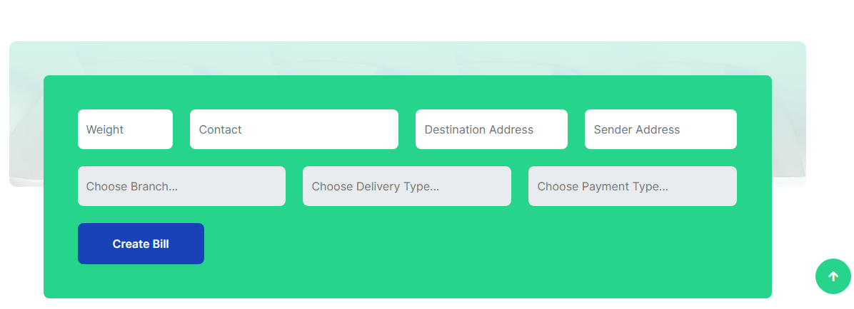

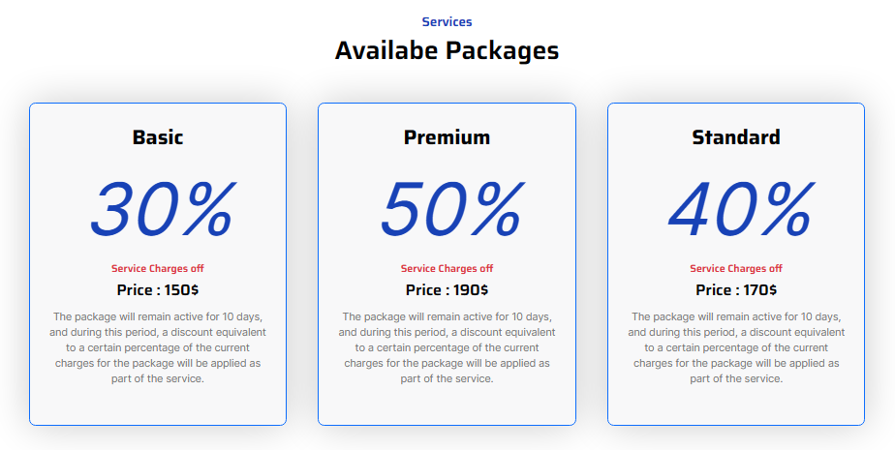
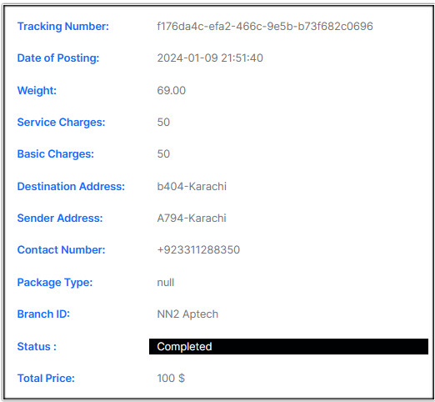
Customer Specification:
The application should independently calculate the charges, considering the service type, destination location, and the weight of the deliverable. During the payment order process, the user pays using Stripe. If the user desires a discount on the charges, they can also obtain a discount package and Customers are provided with the option to check the details of the items they have sent by using the given delivery number.

Services & Check Delivery Details

Project Plans:


The project plan aims to deliver exceptional service to users by ensuring swift responses to their posted queries. This involves a commitment to timely and thorough replies, enhancing user satisfaction. The focus is on providing a seamless experience, addressing user concerns promptly and effectively. The project's success will be measured by the level of user satisfaction achieved through efficient responses to their postings. Continuous improvement and user engagement are key elements in the execution of this plan.

E-R DIAGRAMS
Two type of E-R diagram us in Project
1) Without Relation
2) With Relation

Without Relation:

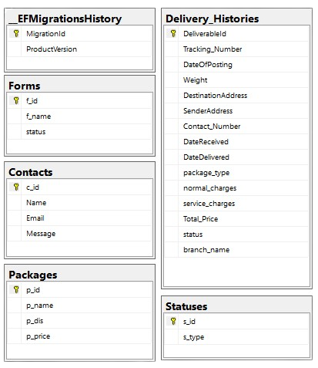
With Relation:

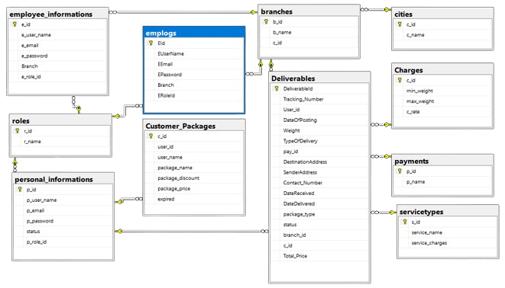
The database has been created with relationships, enhancing the program's speed and overall performance.

Algorithm:

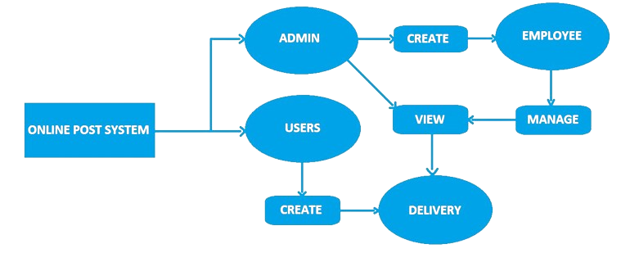
The project is outlined with an algorithm and flowchart, providing a concise description of its structure and processes.

GUI Document & Interface Design

In the user and guest templates, the primary-blue Navbar has a white background, while there are instances of black and light green in various sections. Additionally, the templates include pages for about, contact, and services. The user template also features an extra page dedicated to searching for delivery details.
User & Guest Theme:

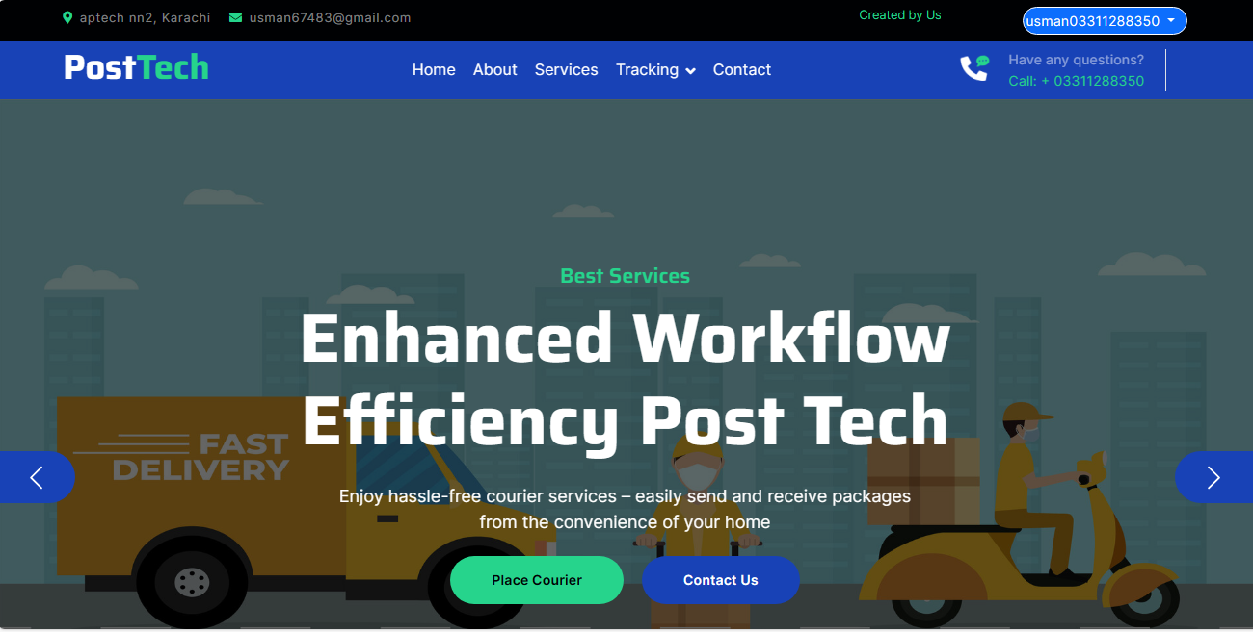

Admin & Employee Theme:

In the admin and employee themes, the navigation features a background with a mix of white and wheat colors. The nav-link exhibits a hover effect with a gradient of blue or light blue against the white background. The admin theme includes pages for charges, update, delivery type, and form status, while the employee theme features pages for editing user deliveries.
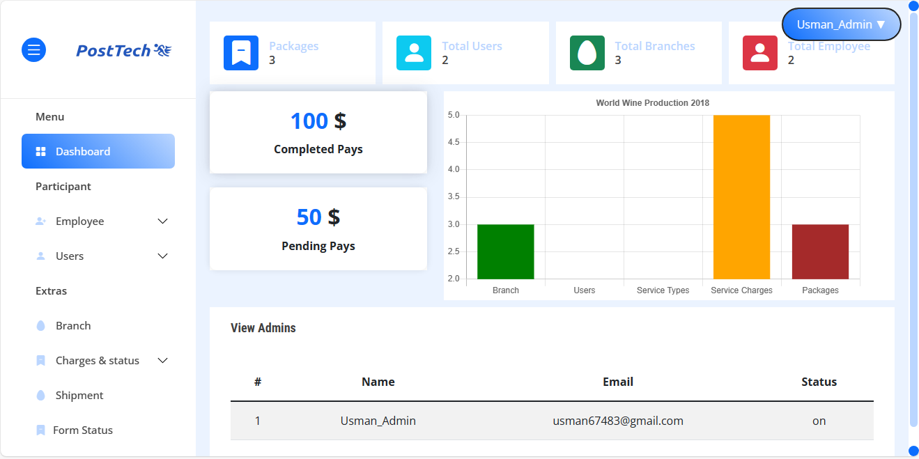

Task Sheet

Usman Ahmed (std1422606):

Role: Completed the entire backend and frontend work, serving as the lead for the group.

Haider Faraz (std1369966):

Role: Assisted in frontend tasks and contributed to the presentation.

Sana Yousuf (std1342491):

Role: Responsible for generating all required content.

Hammas Ali (std1367624):

Role: Acquired proficiency in various skills throughout the project.



Project Review
&
Monitoring Report
The project review and monitoring report highlight the commendable performance of the project despite encountering challenges such as computer issues and complications with the ASP software. Despite these obstacles, with the help of Allah, the team successfully developed the project "Online Post Tech."



Unit Testing

In-depth testing has been conducted for every unit and component in the project, ensuring their robust functionality. The results indicate that each element performs exceptionally well. Moreover, each component brings a unique feature or functionality to the project, contributing to its overall versatility. This meticulous evaluation has played a crucial role in maintaining the high quality of the project.



Final Testing

Every component, feature, and requirement of the project has been meticulously addressed, ensuring their completion and satisfaction. Rigorous testing and verification procedures were implemented before the project's delivery to guarantee its quality and alignment with specified criteria. This thorough evaluation has fortified the project's overall reliability and performance. We are confident that the project is poised to meet or exceed expectations upon delivery.



Documentation End

